Paper Text (MALUMAT_1.1)

HEADING (MALUMAT_1.2.)

Name Last Name(1) ,Name Last Name2 and Name Last Name (2,) * (MALUMAT_1.3.)

|  |
| --- |
| Citation: To be added by the editor.  Date of Arrival: Day/Month/Year Acceptance Date: Day/Month/Year  bilardo topu, daire, ekran görüntüsü içeren bir resim  Açıklama otomatik olarak oluşturuldu  **Telif Hakkı:** © 2023. (CC BY) (https://creativecommons.org/licenses/by/4.0/). |

1 1. Author's imprint ;e-mail@e-mail.com , ORCID: (MALUMAT_1.6))

2 2. Author's bio:e-mail@e-mail.com , ORCID: (MALUMAT(1.6))

**\*** Corresponding author:e-mail@e-mail.com (MALUMAT_1.6))

**Abstract:** word range should be 150-250. In research articles, abstracts should describe the general framework of the study. In the abstract, the purpose of the study and the research question should be clearly stated. The methodology followed should be explained. The findings should be written briefly and the results should be interpreted. The purpose of the abstract should be a brief presentation of the study. (MALUMAT_1.7)

**Keywords**: 1st keyword, 2nd keyword, 3rd keyword (MALUMAT_1.8)

**Jel Codes:** at least 3 gel codes related to the subject of the study should be included (MALUMAT_1.8)

Turkish Title (MALUMAT_2.2.)

**Abstract:**A single paragraph of 150-250 words. A single paragraph of 150-250 words. A single paragraph of 150-250 words. A single paragraph of 150-250 words. A single paragraph of 150-250 words. (MALUMAT1.7)

**Keywords:** 1. Keyword, 2. Keyword, 3. Keyword (MALUMAT_1.8)

**Jel Codes:** At least 3 jel codes should be added. (MALUMAT_1.8)

1. How to use the template?

While preparing your article, download the MALUMAT article template file in blank format. Do not upload your article to this file, but to the FILE NAMED MALUMAT ARTICLE TEMPLATE. THIS FILE WILL BE USED FOR INFORMATION ON HOW TO USE THE TEMPLATE.

There is a style for each section in the styles menu of Microsoft Word. For each type of article content such as headings, text, tables, figures, etc., it is necessary to select the relevant section and apply the required style.

For main headings, MALUMAT_2.1 for first order headings, MALUMAT_2.3 for second order headings and MALUMAT_2.2 for English abstract headings should be selected from the styles section. For text, MALUMAT_3.1._ MALUMAT_3.3 for spaces before paragraphs and MALUMAT_3.4 for spaces after paragraphs.

1. Figures, tables

After the shapes are added, MALUMAT_5.2 style should be selected from the styles pane. Captions of the shapes should be under the shapes and MALUMAT_5.1 style should be selected.



**Figure1.** MALUMAT logo (Figure captions should appear below the figures.) (MALUMAT_5.1

**Table1.** Table title (MALUMAT_4.1)

|  |  |  |
| --- | --- | --- |
| Title1 | Title2 | Title3 |
| Information1 | Data | Data |
| Information1 | Data | Data |

1Note to the tables

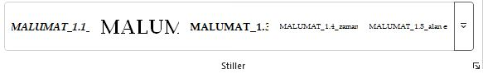

**Figure** 2. Word Styles pane

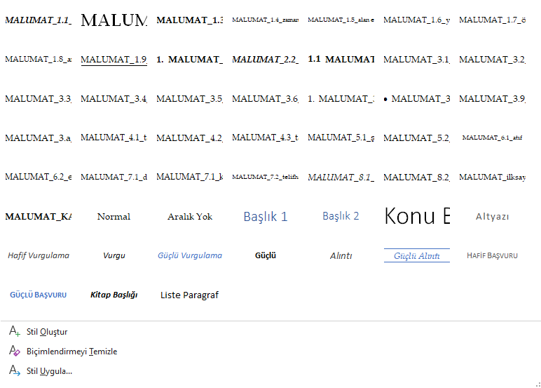

**Figure3.** Word Styles pane 2

The text is adapted to the template by selecting the relevant field from the styles section in the input pane.

1. Mathematical expressions

Choose the appropriate style for equations, theorems and proofs.[1]

|  |  |
| --- | --- |
| a = 1, | (1) |
| a = b + c + d | (2) |

1. Theorems and proofs

If there are theorems and proofs in the article, they should be written by selecting the relevant style.

Theorem 1. Theorem statement (MALUMAT_8.1)

Theorem 1 Proof. Description of proof (MALUMAT_8.2)

Bibliography (MALUMAT_CITATION_TITLE)

Author 1, A.B.; Author 2, C.D. (Year). Article title. Journal name, 3(1), 3-9. (MALUMAT_7.1)

Author 1, A.; Author 2, B. (Year). Chapter Title in Title of the book, 2nd ed.; Ed., A., B., Publishing House: Bookmark , pp. 154-196. Author 1, A.; Author 2, B. (Year). Title of the book, 3rd edition; Publishing House: Yer Bilgi, 2025; pp. 154-196.

Author 1, A.B.; Author 2, C.D.; Author 3, (Year). Presentation Title. Conference title, place where the conference took place (date information)

Author 1, A.B. (Year). Thesis title. Type of thesis, University and institute information.

Law on the regulation of publications on the internet and combating crimes committed through these publications. (2007, May 23). Official Gazette (Issue: 26530). Available at: http://www.resmigazete.gov.tr/eskiler/2007/05/20070523-1.htm

**APPENDICES**

**Examples of in-text citations:**

Single page citation: One author ...(Surname, Year, p.5). Two authors ...(Surname and Last Name, Year, p.5). More than two authors ...(Surname and others, Year, p.5).

Citation to more than one page: Single author ...(Surname, Year, pp.5-7). Two authors ...(Surname and Last Name, Year, pp.5-7). More than two authors ...(Surname and others, Year, pp. 5-7).

In the study conducted by Soyadı (2018)...

In the study conducted by Soyadı in 2018...

According to Surname (2018).

By surname and others (2018)

If abbreviations are used in in-text citations, the first citation at the end of the sentence: (Scientific and Technological Research Council of Turkey [TÜBİTAK], 2013).

Subsequent citations at the end of a sentence: (TÜBİTAK, 2013).

First citation in a sentence: Scientific and Technological Research Council of Turkey (TÜBİTAK, 2013)...

Subsequent citations in a sentence: TÜBİTAK (2013).

Multiple citations in the same parenthesis: (Surname and Surname, 2013; Surname, 2014)

In cases where the original source cannot be accessed (cited by Surname, Year, p.5)

If a specific part of the source is cited: (Surname, 2020, Section 1) (Sugar, 2020, Table 2)

For detailed information: (For more detailed information on this issue, see Soyadı, 2020)

Law cited at the end of the sentence in-text: (Made on the Internet, 2007).

Bibliography: Law on the regulation of publications on the internet and combating crimes committed through these publications. (2007, May 23). Official Gazette (Issue: 26530). Available at: <http://www.resmigazete.gov.tr/eskiler/2007/05/20070523-1.htm>

1. MALUMAT_7.1. Stili seçilerek yazılmalıdır.